10/5/2026
Instructor: Sir Mustajab
Submitted by: Wasif Ali
Reg id: 245187
Class: BSCS F24 B


Git-HUB
Artificial Intelligence Lab 05
Lab No 05
Lab Task 1: Weather Logger
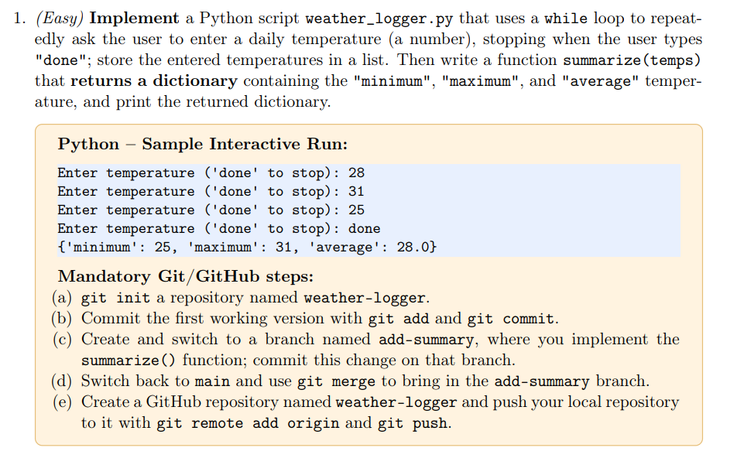
Create Directory and Initialize Git
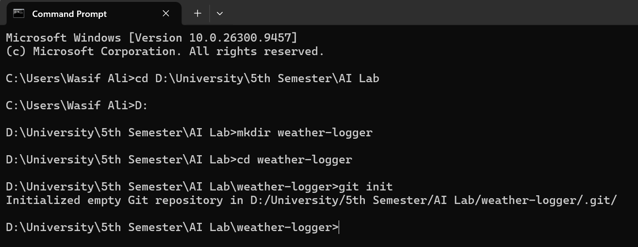

Create Initial Python Script & Commit
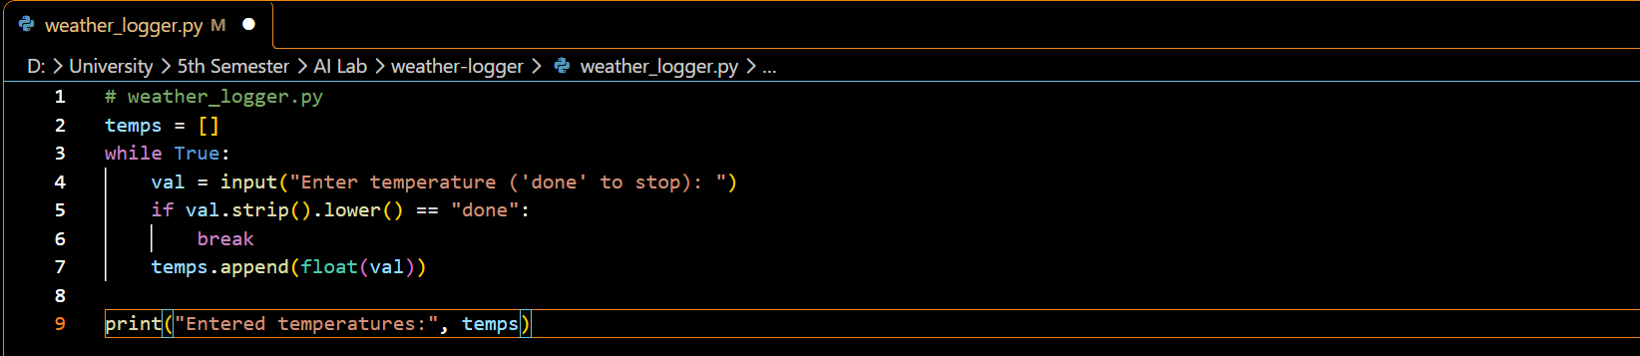
Stage and commit
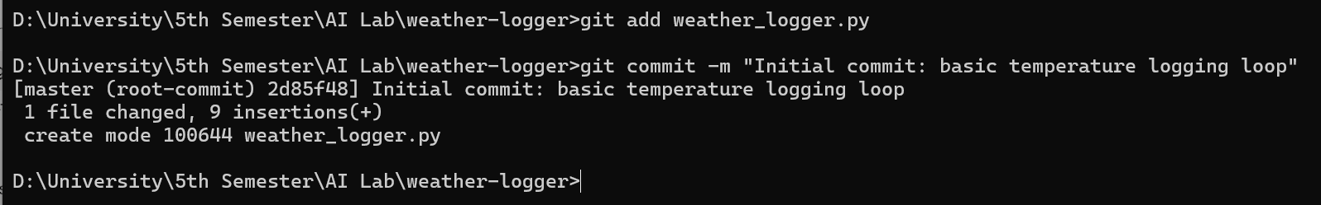
Branching & Feature Implementation
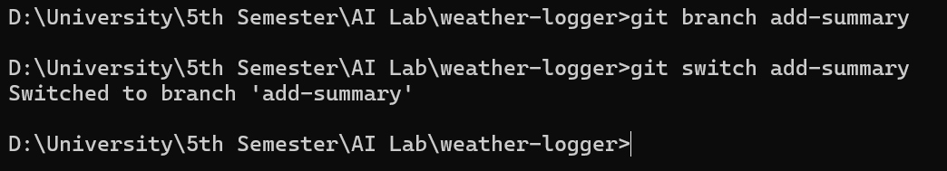
Update weather_logger.py to add summarize(temps)
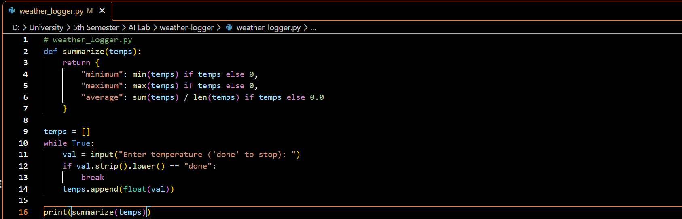
Commit on the branch
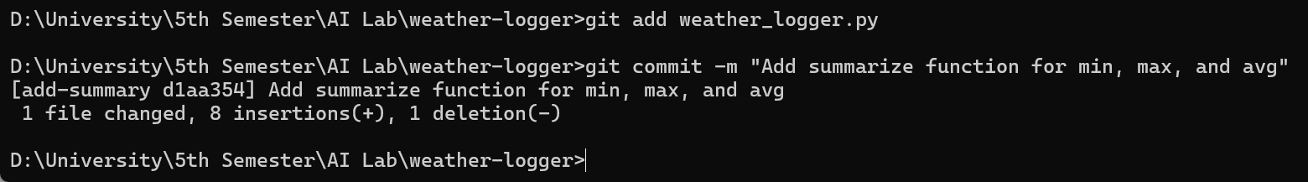
Merge Branch
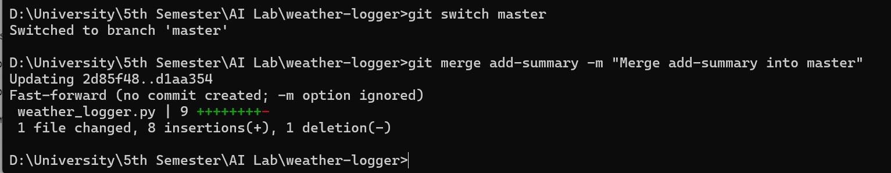
Push to GitHub
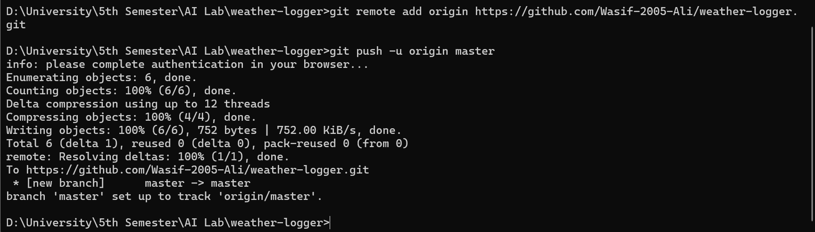

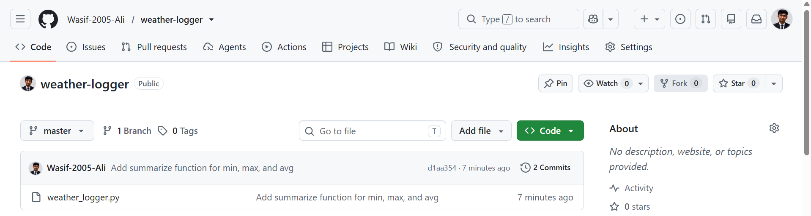
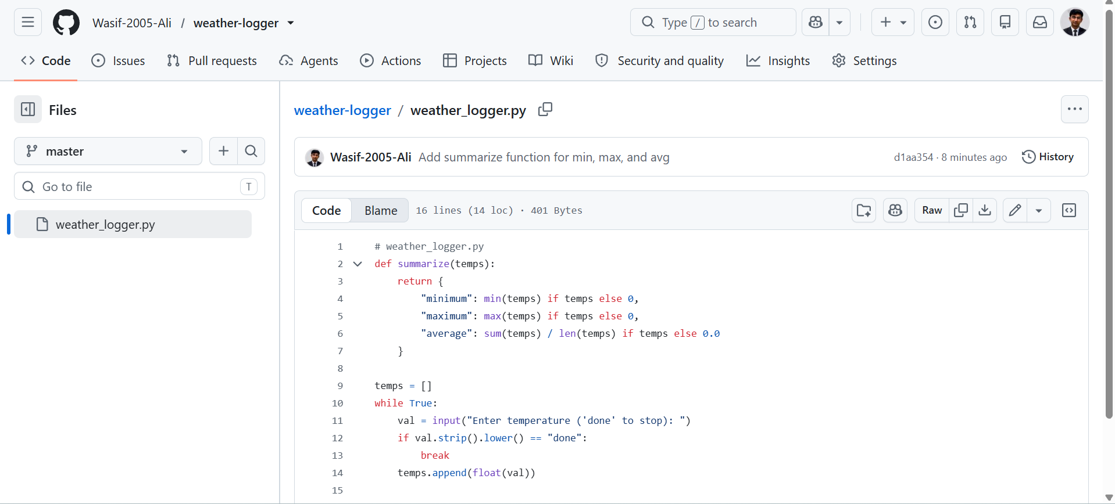

Lab Task 2: Shopping List
Create Directory and Initialize Git
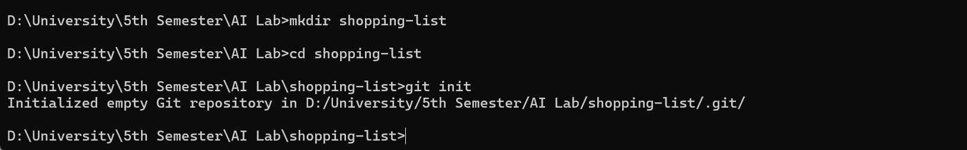
Create Initial Script & Commit
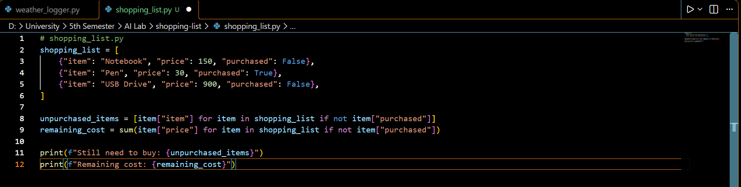
Stage and commit
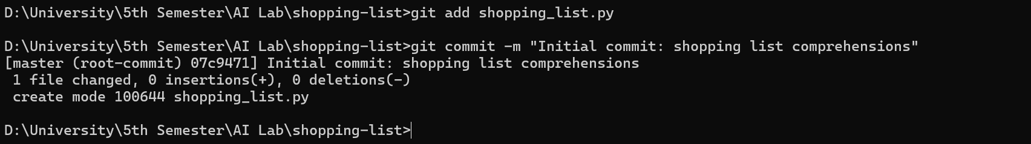
Modify File, Inspect Diff, and Commit
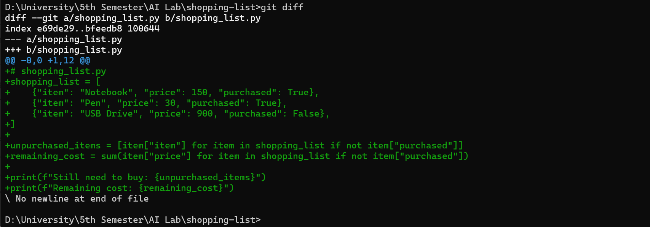
Stage and commit
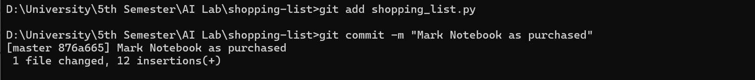
Record Commit History
Push to GitHub
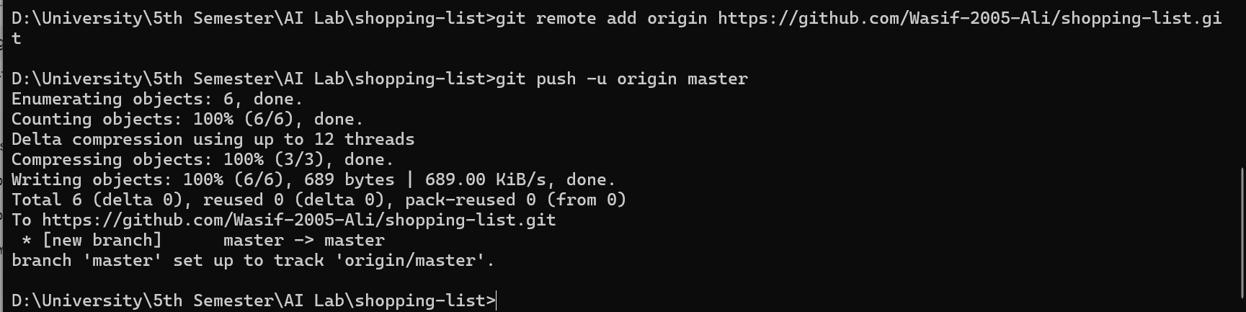
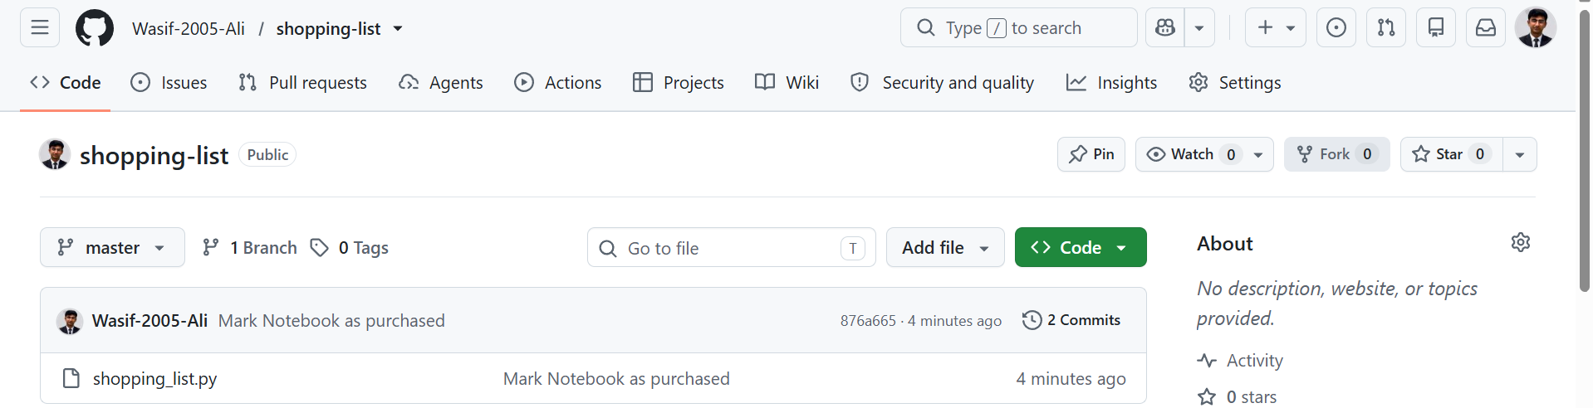
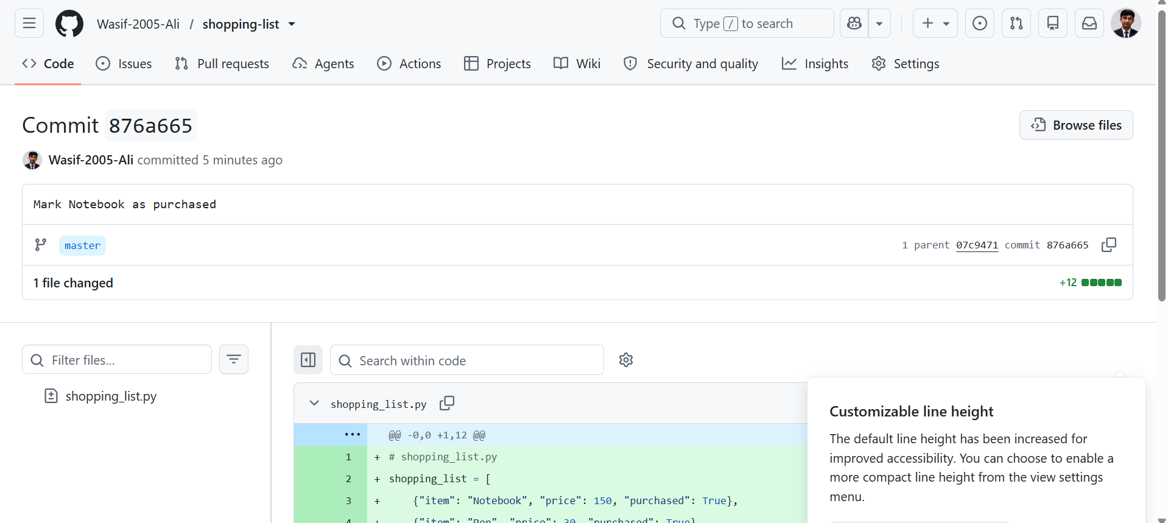

Lab Task 3: Habit Tracker
Create Directory and Initialize Git
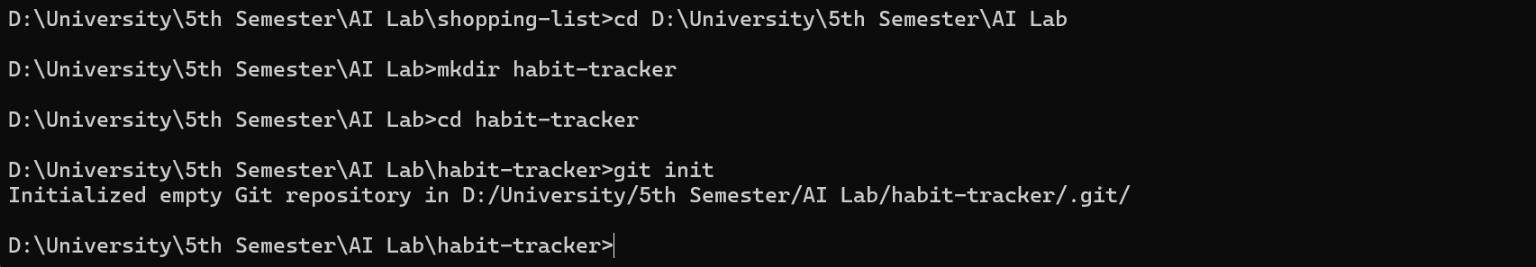
Create Initial Script & Commit
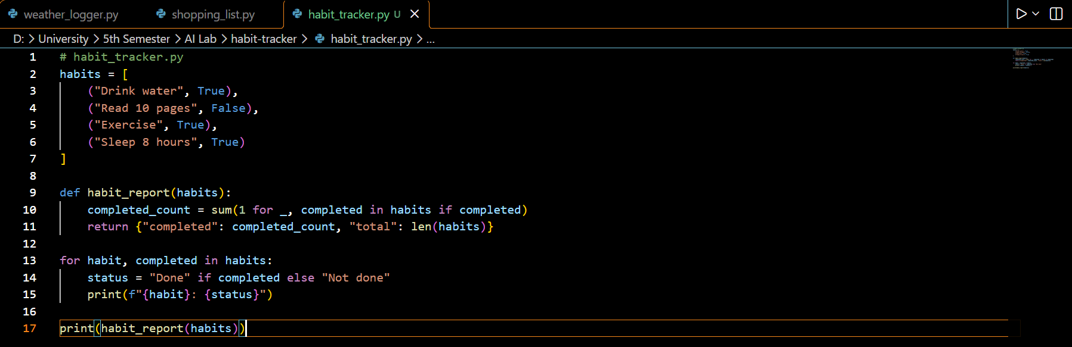

Stage and commit
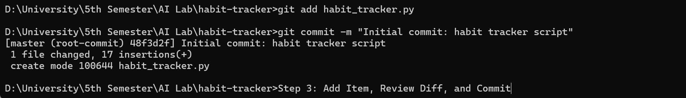
Add Item, Review Diff, and Commit
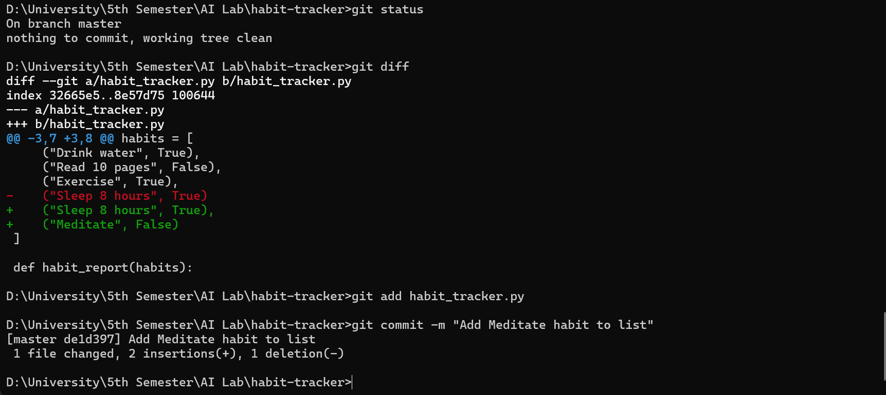
Push to GitHub
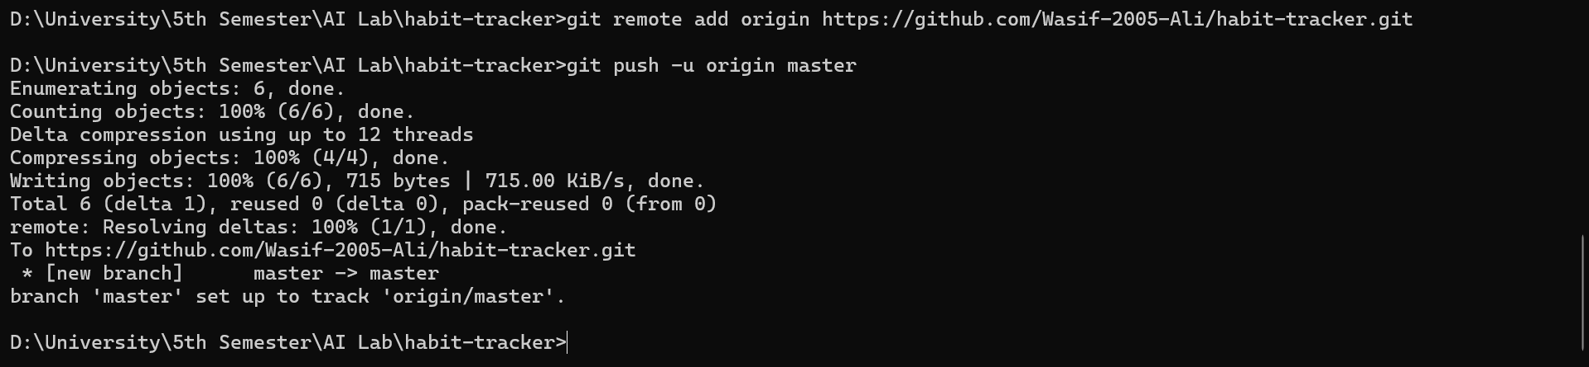
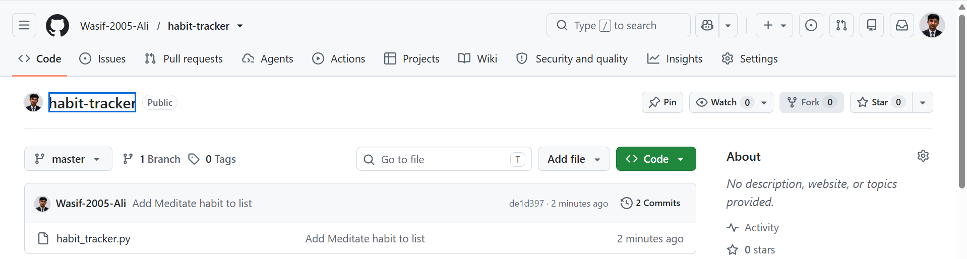
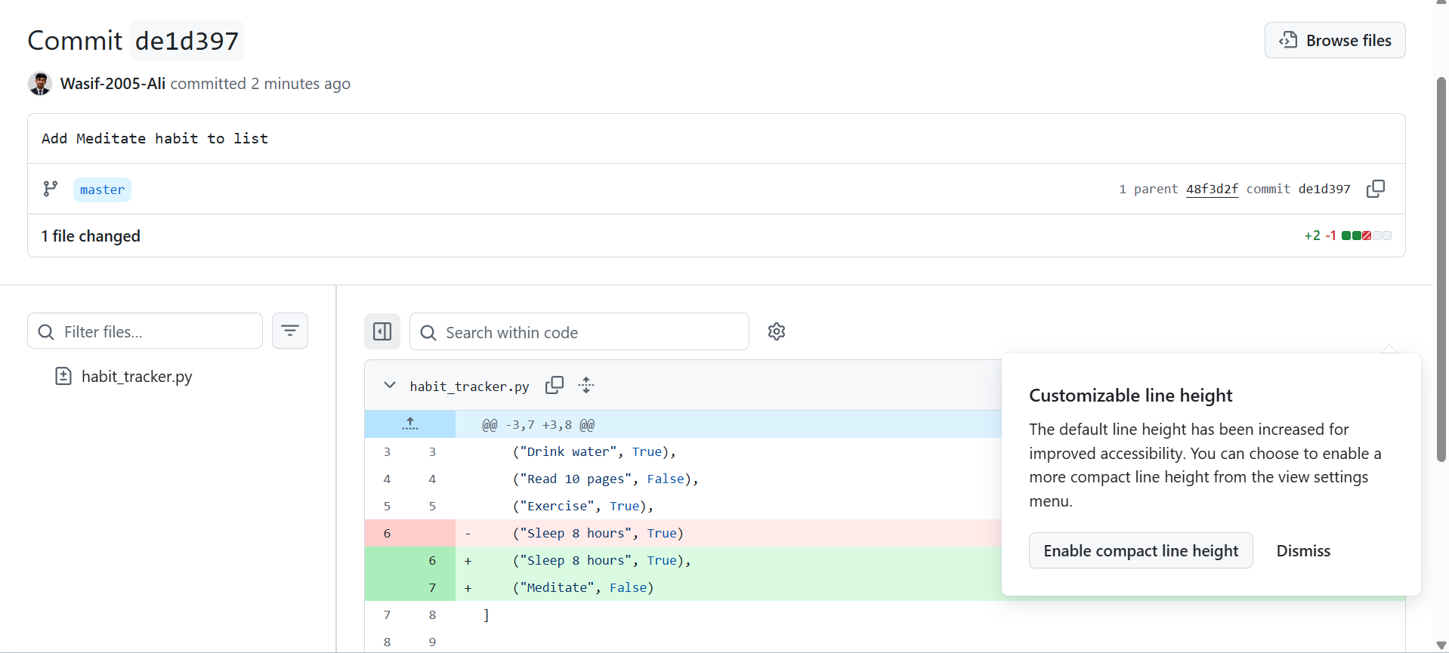

Verify Clone, Remote Edit, and Pull Workflow
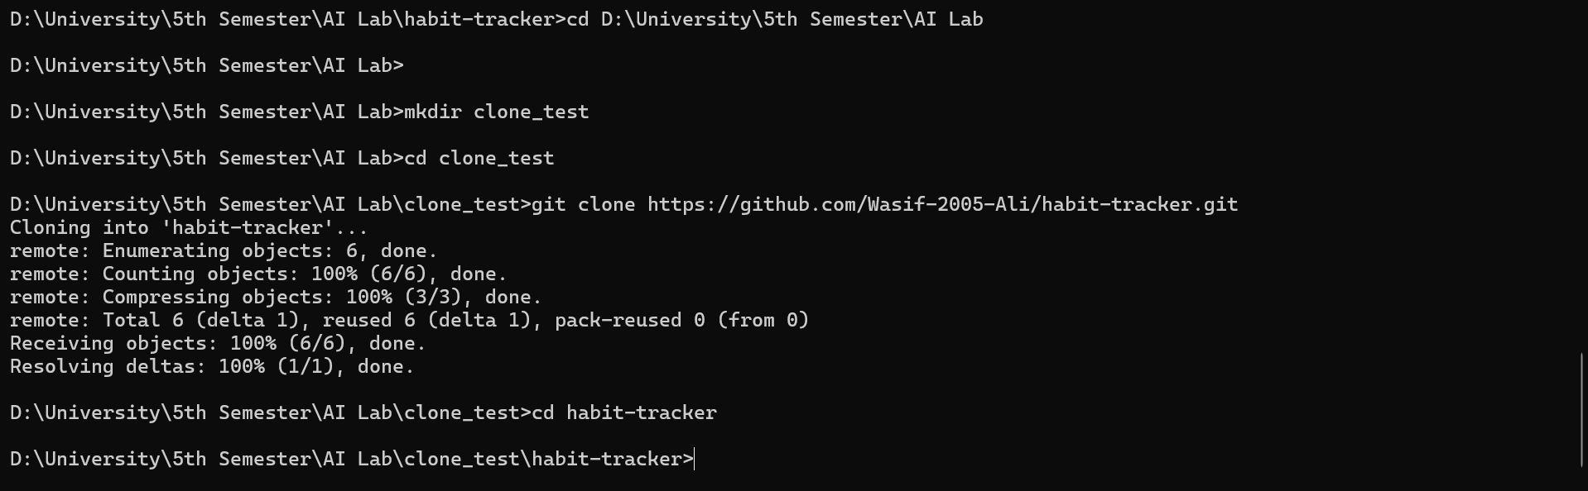
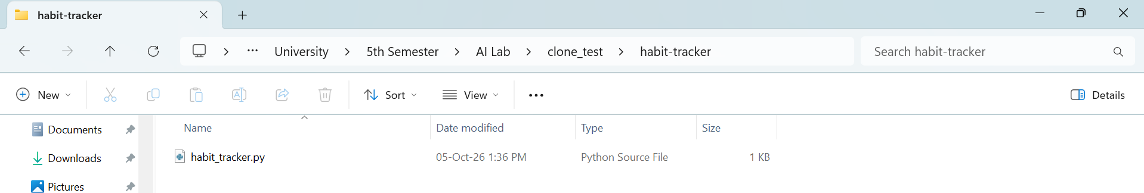

!!SUCCESFULLY PULLED!!
ALL TASK COMPLETED SUCCESFULLY

